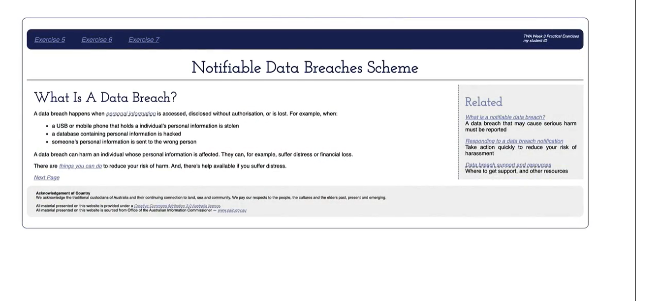

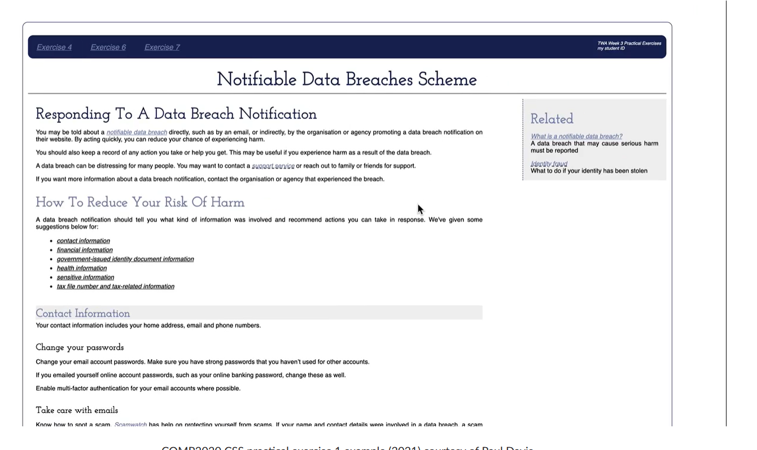

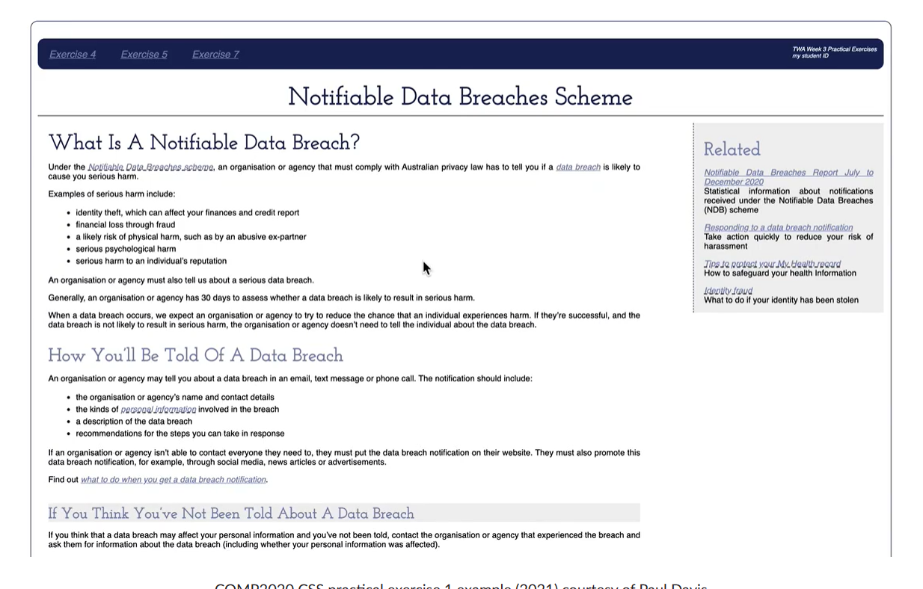

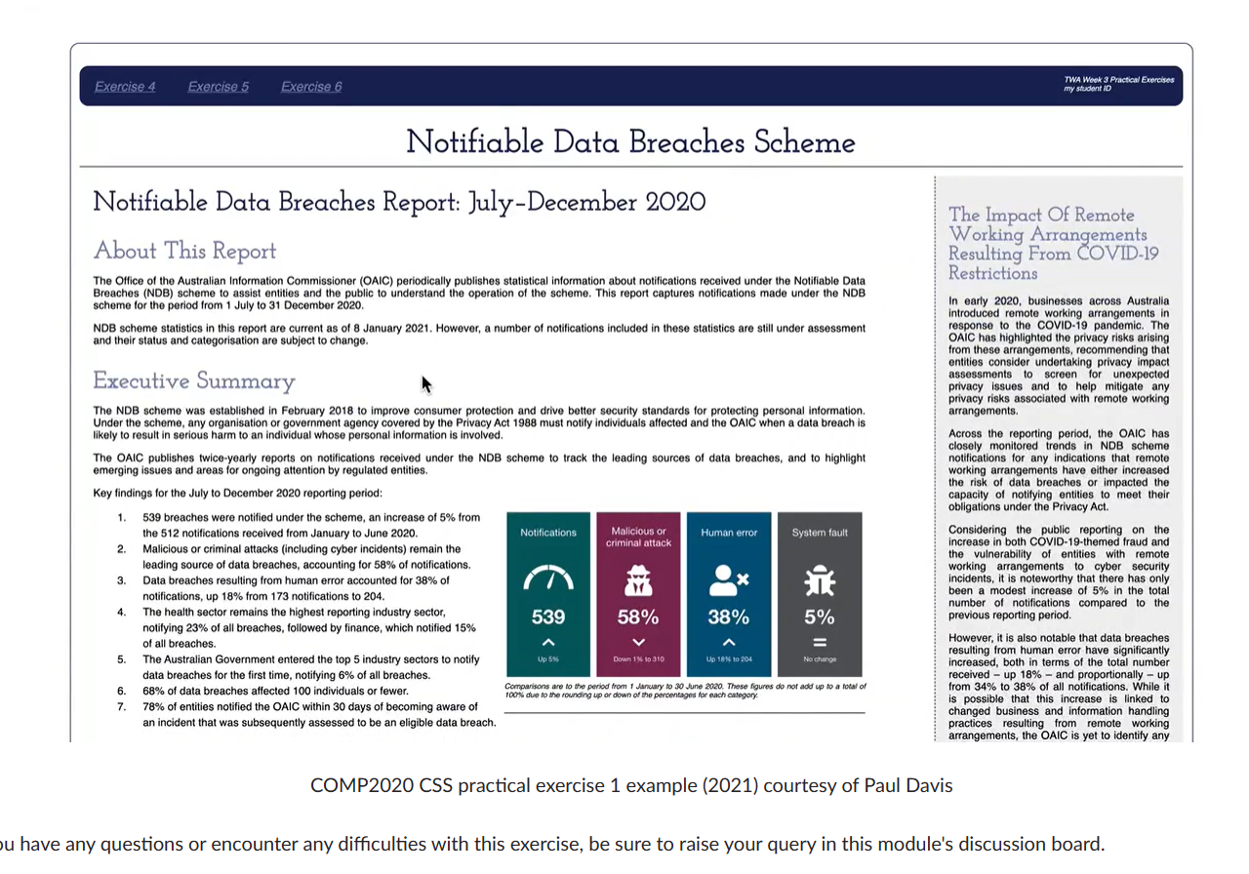

SPECS:

Background colour for the HTML document to be set to white.

Typeface of the HTML document to be a list of fonts in the following order: Helvetica, Arial, Sans-serif.

Font size for the HTML document to be set to 100% of the browser default.

Font colour for the HTML document to be set to black.

The HTML document to have left and right margins of 50 pixels, and top and bottom margins of 50 pixels.

The HTML document is to have a solid 1-pixel border of colour #172457. The border is to have rounded corners with a radius of 10 pixels.

The HTML document is to have left and right padding of 10 pixels, and top and bottom padding of 25 pixels.

There is to be a 2-pixel solid black border between the header section of the document and the rest of the main content.

Typeface for headings H1 to H6 to be set to a list of fonts in the following order: 'Josefin Slab', Georgie, serif.

Hint: 'Josefin Slab' is not a standard web font. You will need to use the Google fonts (Links to an external site.) (Google, 2021) repository.

H1 headings are to be 300% of the browser default font size, with text colour of #172457, a bottom margin of 20% of the browser default font size and must be centred.

H2 headings are to be 250% of the browser default font size, with text colour of #172457, a bottom margin of 20% of the browser default font size, and each first letter of each word capitalised.

H3 headings are to be 220% of the browser default font size, with text colour of #7B85AD, a bottom margin of 20% of the browser default font size, and each first letter of each word capitalised.

H4 headings are to be 180% of the browser default font size, with text colour of #7B85AD, background colour of #f0f0f0, top padding of 5 pixels, a bottom margin of 20% of the browser default font size, and each first letter of each word capitalised.

H5 headings are to be 140% of the browser default font size, a bottom margin of 30% of the browser default font size, with text colour black.

Unordered lists and ordered lists are to have 1.5 line spacing.

Paragraphs should use full-text justification.

List items that are in ordered lists are to use left padding of 15 pixels.

There are three images displayed in the exercise 7 page each with its own caption. Each of these images was given width and height values in the week 1 exercises. Keep these width and height values in your HTML for these images. Change the display of these images and their captions using CSS as follows:

Figure1.jpg must not reduce smaller than 300 pixels wide or increase larger than 400 pixels wide as the browser is resized, be displayed on the right-hand side of the page such that the ordered list text wraps around it to the left (none of the following page content should wrap around the image) and have left padding of 25 pixels. The image is to have auto margins. The caption of this image is also to be bound by this width.

Chart1.svg and Chart2.svg must not reduce to smaller than 300 pixels wide or increase larger than 700 pixels wide as the browser is resized, be displayed in the centre of the column, left and right padding of 15 pixels, and top and bottom padding of 10 pixels. The images are to have auto margins. The captions of these images are also to be bound by this width.

All three of the images must not be allowed to resize to a larger size.

The captions for these images are to use full-text justification, have 15-pixel padding at the bottom, use a font size that is 70% of the browser default font size, be displayed in italics, and have a solid 1-pixel black border underneath the caption

The navigation section at the top of the page is to have a background colour of #172457 with a font size that is 120% of the browser default font size and is to have rounded corners with a radius of 10 pixels.

Hypertext links within the navigation section are to be displayed using white text colour and when the mouse hovers over the link the background colour is to change to #7B85AD and is to have rounded corners with a radius of 10 pixels.

Each hypertext link within the navigation section is to have top and bottom padding of 14 pixels, and left and right padding of 16 pixels, and should use centred text alignment.

Hint: to achieve the same layout as shown in the screenshots you may need to investigate the display CSS property.

Hypertext links that are not in the navigation section are to have text colour of black and displayed in italics. If the link has previously been loaded by the browser then the text colour is to be #7B85AD.

Hypertext links that are to external web pages are to be displayed with a black dashed underline.

The top two lines of the page ‘TWA Week 3 Practical Exercises’ and ‘my Student ID’ must be displayed to the right of the page (overlaying the navigation bar), have padding at the top and on the right of 10 pixels, be in italics at 70% of the browser default font size and using a text colour of white.

The Acknowledgement of Country and Copyright notice at the bottom of the page is to inherit its text colour, using a font size that is 70% of the browser default font size. This section is also to have a background colour of #f0f0f0, left and right padding of 20 pixels, top and bottom padding of 2 pixels and has rounded corners with a radius of 10 pixels. The first paragraph in this section should not have a top margin.

The HTML pages will have a two-column display. The column on the left must be 70% of the available space inside the page borders and have left and right padding of 15 pixels. The right column must be 20% of the available space inside the page borders and have left and right padding of 15 pixels. Most of the content of the page will appear in the left-hand column. The right-hand column will be used for the ‘related’ article links and discussion of the ‘impact of remote working arrangements from COVID-19’.

In exercises 4, 5, and 6 there is a section headed ‘Related’, and in exercise 7 headed ‘The impact of remote … Restrictions’. These sections on each page should be displayed to the right of the page such that the main content of each page displays to the left of this section. The right-hand side section starts 10 pixels below the borderline underneath the main page heading, has a bottom margin of 10 pixels, has a background colour of f0f0f0, a left-side dashed border that is 1 pixel wide and colour of 172457.